Heat loss in animals

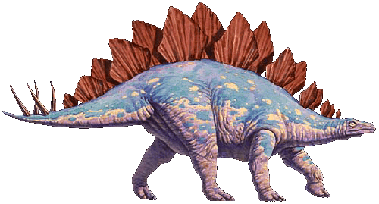

Some animals help regulate their body temperature by heat loss through their ears. Choose an animal, it can be an extinct animal, and research how it absorbs and emits heat.
Your research should be presented as a Power Point (or similar)
Don’t forget a bibliography !!!

